September 2024

**Based on the version of J. LINARES (REVIEWED 2021) (Further amendments: March 2022, April 2022, May 2022)**

Child protection and safeguarding (including Safer Recruitment)

**Table of contents:**

1.Introduction

2. What do we mean by Child protection and safeguarding?

3. Vulnerability

4. Education-roles and responsibilities

5.Role of outside agencies

6.Intervention and procedure

7. Dealing with a disclosure

8.Making a MARF

9. Unsubstantiated allegations

10. Low level concerns

11. Allegations of abuse against other pupils

12.Chils on child abuse

13.UK MOD pupils

14. Providing support

15. Confidentiality and information sharing

16. Online safety

17. AI

18. Non collection of children

19. Missing pupils

Points to remember

***Appendices:***

1: Safer recruitment

2: Radicalisation

3.MARF

4. MOD MARF

**Information in blue has been added by Hebrew Primary School**

# INTRODUCTION

## Who is this policy for ?

The direction and guidance contained in this document is for all members of the Department of Education Advisory Team, school leaders and staff in all government schools and educational settings in Gibraltar, all government nurseries and the Gibraltar College. (For ease of reference, throughout this document, all establishments will be referred to as ‘schools’.)

## Aims, Values and Principles

The Gibraltar Department of Education is committed to keeping children safe and ensuring public confidence in safe practices within its schools.

Not only are children and young people in Gibraltar entitled to a high standard of education in an environment where they feel protected, but they are also entitled to feel safe wherever they are. Everybody in society has a duty to keep children safe, and teachers and education staff are no exception. This policy strongly advocates that teachers and education staff are obliged to report any suspicions that children are not safe outside as well as inside of the school environment.

The Department of Education will provide guidelines and advice, and support schools in the deployment of their safeguarding work. It recognises that this work is not simply about reporting incidents or disclosures when they occur, but requires a whole education strategy and the engagement of the wider school community who work together for the successful implementation of policy, procedures and preventative strategies. Schools must take steps to ensure a consistent approach to all forms of abuse and safeguarding concerns.

**STATUTORY REQUIREMENTS & OTHER GUIDING PRINCIPLES**

There are a number of Gibraltar laws which compel us to address our approach to safeguarding children - these form our statutory requirements.

## Gibraltar Laws

* Education and Training Act 1974
* Equal Opportunities Act 2006
* Children’s Act 2006
* Communications Act 2006 (combating Child Pornography)
* Care Agency Act 2009
* Crimes Act 2011
* Disability Act 2017

## Other Guiding Principles

There is also substantial research-based legislation; policy and guidance issued by DFE, OFSTED and the Gibraltar Care Agency which relates to Safeguarding, these along with input from local teachers and schools have helped to form the guiding principles of this policy.

* WHO – Growing up unequal: gender and socioeconomic differences in young people’s health and well-being 2016
* Gibraltar Professional Code of Conduct for Teachers, 2017
* Ofsted – Safeguarding Policy March 2018
* DFE – Keeping Children Safe in Education September 2018
* DFE – Working Together to Safeguard Children July 2018
* Maximising School Attendance in Gibraltar 2021
* Local schools – existing policy and practice
* Gibraltar Care Agency Policies

# WHAT DO WE MEAN BY CHILD PROTECTION & SAFEGUARDING?

## Definition

***Safeguarding*** aims to promote the welfare of children and refers to the process of protecting children from maltreatment, preventing the impairment of health or development, ensuring that children grow up in circumstances consistent with the provision of safe and effective care, and taking action to enable all children to have the best outcomes.

***Child protection*** refers to the processes undertaken to protect children who have been identified as suffering, or being at risk of suffering, significant harm.

## Types of abuse

Failure to safeguard a child can be categorised under one of the 4 types of abuse outlined below.

***Physical abuse*** is a form of abuse which may involve hitting, shaking, throwing, poisoning, burning or scalding, drowning, suffocating or otherwise causing physical harm to a child. Physical harm may also be caused when a parent or carer fabricates the symptoms of, or deliberately induces, illness in a child.

***Emotional abuse*** is the persistent emotional maltreatment of a child such as to cause severe and persistent adverse effects on the child’s emotional development. It may involve conveying to a child that they are worthless or unloved, inadequate, or valued only insofar as they meet the needs of another person. It may include not giving the child opportunities to express their views, deliberately silencing them or ‘making fun’ of how they communicate. It may feature age or developmentally inappropriate expectations being imposed on children. These may include interactions that are beyond a child’s developmental capability, as well as overprotection and limitation of exploration, or preventing the child from participating in normal social interaction. It may involve seeing or hearing the ill-treatment of another. It may involve serious bullying (including cyber bullying), causing children frequently to feel frightened or in danger, or the exploitation or corruption of children. Some level of emotional abuse is involved in all types of maltreatment of a child, although it may occur alone.

***Sexual abuse*** involves forcing or enticing a child or young person to take part in sexual activities, whether or not the child is aware of what is happening. The activities may involve physical contact, including assault by penetration or non-penetrative acts such as masturbation, kissing, rubbing and touching outside of clothing. They may also include non-contact activities, such as involving children in looking at, or in the production of, sexual images, watching sexual activities, encouraging children to behave in sexually inappropriate ways, or grooming a child in preparation for abuse (including via the internet). Sexual abuse is not solely perpetrated by adult males. Women can also commit acts of sexual abuse, as can other children.

***Neglect*** is the persistent failure to meet a child’s basic physical and/or psychological needs, likely to result in the serious impairment of the child’s health or development. Neglect may occur during pregnancy as a result of maternal substance abuse. Once a child is born, neglect may involve a parent or carer failing to: provide adequate food, clothing and shelter (including exclusion from home or abandonment); protect a child from physical and emotional harm or danger; ensure adequate supervision (including the use of inadequate care-givers); ensure access to appropriate medical care or treatment. It may also include neglect of, or unresponsiveness to, a child’s basic emotional needs or failure to provide education.

***There are a number of sub-categories of abuse which are specific or fall under the umbrella of a number of different types of abuse.***

***Sexual exploitation of children*** involves an individual or group of adults taking advantage of the vulnerability of an individual or groups of children or young people, and victims can be boys or girls. Children and young people are often unwittingly drawn into sexual exploitation through the offer of friendship and care, gifts, drugs and alcohol, and sometimes accommodation. Sexual exploitation is a serious crime and can have a long-lasting adverse impact on a child’s physical and emotional health.

***Domestic Abuse*** involves any incident or pattern of incidents of controlling, coercive or threatening behaviour, violence or abuse between those aged 16 or over who are or have been intimate partners or family members regardless of gender or sexuality. This can encompass but is not limited to the following types of abuse:

* Psychological/emotional abuse- intimidation and threats, social isolation, verbal abuse, humiliation, constant criticism, enforced trivial routines, marked over intrusiveness
* Physical violence - slapping, pushing, punching, kicking, biting, stabbing, damage to property or items of sentimental value
* Physical restriction of freedom - controlling who the partner or child/ren see or where they go, what they wear or do, stalking, imprisonment, forced marriage;
* Sexual violence - any non-consensual sexual activity, including rape; sexual assault; sexual exploitation, refusing safer sex; or human trafficking; and
* Financial abuse - stealing, depriving or taking control of money, running up debts, withholding benefits books or bank cards

Even witnessing or just being aware of this type of abuse can have an immense negative impact on a child’s emotional development.

***Radicalisation and Extremism*** is defined by the UKgovernment as vocal or active opposition to fundamental British values, including democracy, the rule of law, individual liberty and mutual respect and tolerance of different faiths and beliefs.

Some children are at risk of being radicalised: adopting beliefs and engaging in activities which are harmful, criminal or dangerous.

Schools should remain alert to the risk of radicalisation into any type of extremism. Gibraltar does not have any recorded incidents of this type of concern or abuse but we should remain vigilant.

## Vulnerability

Some children may be at increased risk of abuse. Many factors can contribute to an increase in risk, including prejudice and discrimination, isolation, social exclusion, communication issues and reluctance on the part of some adults to accept that abuse can occur. To ensure that all of our pupils receive equal protection, we will give special consideration to children who are:

* disabled or have special educational needs
* young carers
* affected by parental substance misuse, domestic violence or parental mental health needs; criminality
* asylum seekers
* living away from home
* vulnerable to being bullied, or engaging in bullying
* living in temporary accommodation
* living transient lifestyles
* living in chaotic and unsupportive home situations
* vulnerable to discrimination and maltreatment on the grounds of race, ethnicity, religion or sexuality
* at risk of sexual exploitation
* do not have English as a first language
* at risk of female genital mutilation (FGM)
* at risk of forced marriage
* at risk of being drawn into extremism

This list provides examples of additionally vulnerable groups and is not exhaustive.

**If you have a concern about mental health**

Mental health problems can, in some cases, be an indicator that a child has suffered or is at risk of suffering abuse, neglect or exploitation.

Staff will be alert to behavioural signs that suggest a child may be experiencing a mental health problem or be at risk of developing one.

If you have a mental health concern about a child that is also a safeguarding concern, take immediate action by contacting the DSLs.

If you have a mental health concern that is **not** also a safeguarding concern, speak to the DSL to agree a course of action.

# 4.EDUCATION: ROLES & RESPONSIBILITIES

## The Department of Education

The safeguarding of children under the care of the Director of Education should always be a priority. All members of the Department of Education Advisory Team have a duty to support the work of all Designated Safeguarding Leads (DSLs) and all staff in schools in the discharge of their duties to safeguard children. They should have an understanding of the issues, processes and protocols that schools use to keep children safe. They should ensure that all personnel working in schools have been given the appropriate safeguarding checks.

The Education Adviser for Child Welfare has a core responsibility to support schools by:

* Liaising regularly and being available to DSLs to assist them in their duties to identify and refer safeguarding concerns to the appropriate authorities.
* Liaising regularly and being available to DSLs to assist them in their duties to monitor children: on the Child Protection register; on CIN plans; who are LAC; who are more vulnerable; who there are concerns about.
* Liaising with key school staff to agree referrals and intervention for pupils whose absences from school are causing concern.
* Ensuring that they access necessary CPD and maintain a sound knowledge and understanding of current safeguarding procedures and associated issues.
* Providing in-service training, advice and guidance to DSLs and all school staff on child protection and child safeguarding matters.
* Assisting outside agencies, in particular Care Agency and RGP, by: providing appropriate information; aiding communication and flow of information between schools and themselves; facilitating training opportunities provided by these agencies.
* Contributing to the multi-agency forums as regards Child Safeguarding matters.
* Monitoring and evaluating of education otherwise than at school.
* Discharging a duty in regard to children missing from education.

## Schools’ Designated Safeguarding leads (DSLs)

Every school must have a designated safeguarding lead and an additional person identified to assist the DSL or stand in for them in their absence. At HPS, Mrs Posen, Mr Azopardi and Mrs Belilo are DSLs.

Appointed DSLs and assistant DSL in local government schools -

* *Primary sector and St Martin’s School:* Headteacher and Deputy Headteacher.
* *Westside/Bayside:* Deputy Headteacher (Pastoral) and one other appointed member of staff.
* *Gibraltar College*: Head of Student Services and one other appointed member of staff.

The DSL has a responsibility to safeguard the children in their specific school by:

* Liaising regularly and being available to the Education Adviser for Child Welfare regarding all issues relating to safeguarding and child protection in their school.
* Liaising regularly and being available to all school staff to assist them in their duties to identify and refer safeguarding concerns.
* Liaising regularly and being available to teaching staff to assist them in their duties to monitor children in their school who: are on the Child Protection register; are on CIN plans; are LAC; are more vulnerable; there are concerns about.
* Liaising with teaching staff to agree referrals and intervention for pupils whose absences from school are causing concern.
* Ensuring that they access necessary CPD and maintain a sound knowledge and understanding of current safeguarding procedures and associated issues.
* Providing advice and guidance to all school staff on child protection and child safeguarding matters.
* Assisting outside agencies, in particular Care Agency and RGP, by: providing appropriate information; aiding communication and flow of information between schools and themselves; facilitating training opportunities provided by these agencies.
* Contributing to the multi-agency forums as regards Child Safeguarding matters: Child Protection conferences and reviews; Child in Need (CIN) meetings; LAC reviews; strategy meetings.
* Ensuring the collection of safeguarding information as regards children newly enrolling in their specific school and ensuring the passing on of information on their departure from their school.
* Promoting and supporting staff welfare and recognising the potential impact safeguarding issues can have on the emotional wellbeing of staff.
* Ensuring that all external persons working with children are vetted.

## All Teaching and Support Staff

All teaching staff have a responsibility to safeguard the children in their school by:

* Nurturing and maintaining a good rapport with pupils by showing an interest in their wellbeing and being actively involved in their school/college life. This will help develop a culture of trust and respect and will facilitate the communication of any concerns.
* Conducting themselves in a manner which promotes positive and respectful relationships, including having appropriate professional boundaries with students.
* Supporting the DSL in their discharge of duties by understanding correct policies and protocols for identifying concerns and receiving and passing on disclosures and all relevant information.
* Understanding their duty to protect and the implications of professional persistence.
* Monitoring children in their care who: are on the Child Protection register; on CIN plans; are LAC; are more vulnerable; there are concerns about.
* Logging all information clearly, promptly and professionally on CPOMS.
* Attending and actively engaging in regular safeguarding training.
* Read ‘Keeping Children Safe in Education’ part 1.
* Ensure complete confidentiality at all times

**Checking the identity and suitability of visitors**

All visitors will be required to verify their identity to the satisfaction of staff at the front desk and the security guard.

If the visitor is unknown to the setting, we will check their credentials and reason for visiting before allowing them to enter the setting. Visitors should be ready to produce identification.

Visitors are expected to sign the visitors’ book and wear a visitor’s badge.

Visitors to the school who are visiting for a professional purpose, such as educational psychologists and school improvement officers, may be asked to show photo ID and:

Will be asked to show their police check certificate

The organisation sending the professional, such as the educational psychology service, will provide prior written confirmation that an appropriate level of police check has been carried out

All other visitors, including visiting speakers, will be accompanied by a member of staff at all times. We will not invite into the school any speaker who is known to disseminate extremist views, and will carry out appropriate checks to ensure that any individual or organisation using school facilities is not seeking to disseminate extremist views or radicalise pupils or staff.

**5.THE ROLE OF OUTSIDE AGENCIES**

## The Care Agency

The Care Agency (Gibraltar Social Services) is the key agency as regards child protection and the safeguarding of children in Gibraltar. The Care Agency helps schools and the Department of Education discharge their duty to safeguard the children in their care by advising, supporting and delivering training.

Where a child is suspected to be suffering from, or likely to suffer, significant harm, the Care Agency is required by [**Section 99 of the Children Act 2009**](http://www.gibraltarlaws.gov.gi/articles/2009-24o.pdf) to make enquiries, to enable it to decide whether it should take any action to safeguard and promote the welfare of all children in Gibraltar.

Social Work in Gibraltar aims to maintain a holistic, Child Centred focus. This allows and encourages recognising the importance of the support offered by wider family members and friends.

Attempts are made to work with families in Gibraltar before any situation reaches ‘Crisis’, if this is achieved the level of good quality work can be increased, and this should allow for more sustainable changes to be made and families are able to develop their own strategies for future periods of crisis.

Social Workers assess a referral and attribute a level of engagement to the case in hand. This level can change at any point but work is always aimed at bringing the level of engagement to level 1.

***Level 1 - Universal Services***

In Gibraltar, the majority of children have their needs met by Universal Services of education, housing, GHA, and the youth services. There may be occasional and minor additional support from a single agency to assist with a specific problem.

*Level of Social Services involvement*

It would be very unusual for there to be any Social Services involvement at this level.

***Level 2 - Additional Support***

There are times when additional support is needed for a family to return to Level 1. The majority of times that this is required, needs can be met by additional support from the relevant Universal Service provider: Speech and Language Therapists, Physiotherapists, Health Visitors, Opticians, Audiologist, School Counsellors, Education Psychologists, Dietician, and similar.

*Level of Social Services involvement*

Rarely necessary, on occasions when it is necessary, this would be for advice and guidance reasons which would be in line with multi agency working guidelines for the benefit of the child.

***Level 3 - Complex Needs / Child in Need***

If a child or family have multiple needs it may be appropriate for a Multi-Agency co-ordinated response from Children’s Social Services, Therapeutic Services, Health Visitors, Paediatric Services, Education Services, Royal Gibraltar Police. A Social Worker would usually be allocated to the child / family at this stage and would be the Lead Professional.

*Level of Social Services involvement*

There would be a Single Assessment process started with families meeting this threshold, and the case would be allocated to a Social Worker under S20 of the Children Act 2009. This would be considered a Child in Need case within Social Services, and cooperation with parents is encouraged but not statutory.

***Level 4 - Child Protection***

There are times when services and support from Levels 1 – 3 have not prevented the circumstances for a child from deteriorating. In these situations it is necessary and appropriate for these children / families to come under the Child Protection banner.

There is not always a progression from Levels 1 – 3, there are occasions when a child’s needs will jump from Level 1 to Level 4 instantly as a result of a single (but significant) incident which requires services at a Child Protection level. Multi Agency work involving the following agencies is paramount: Royal Gibraltar Police (RGP), Children’s Social Services, Education (individual schools as well as the Advisory Team in the Department of Education), Health (Health Visitor, GHA).

*Level of Social Services involvement*

At this level, Social Work involvement (under S99 of the Children Act 2009) is a statutory service.

## The Royal Gibraltar Police

The police have an essential role in protecting children from abuse and are under a legal duty to carry out their functions taking account of the need to protect and promote the welfare of children. Dedicated child-protection officers receive specialist training in investigating child-abuse cases, but all frontline officers have a crucial role to play in identifying and protecting children.

As well as their duty to investigate criminal offences, the police have emergency powers (Section 99) to enter premises and make sure they can provide immediate protection for children believed to be suffering, or likely to suffer, significant harm.

The police also have a duty to protect and promote the welfare of children in their care and in their custody at all stages of the process.

As well as Education, RGP Officers work with a number of agencies in protecting children: The Care Agency, Gibraltar Health Authority, Multi Agency Public Protection Arrangements (MAPPA). The RGP forms an important part of multi-agency work and holds important information about children who may be suffering, or likely to suffer, significant harm, as well as those who cause this harm, which they should share with other agencies if this is necessary to protect children.

Schools and RGP School Liaison Officers also work together to protect children through preventative work and proactive community policing.

6.**INTERVENTION AND PROCEDURE**

Safeguarding concerns can originate from: observations of behaviours or presentation in a child; sudden changes in behaviour and demeanour; a disclosure directly from a child; or from information received from a third party. Concerns can build gradually or derive from a one off event or disclosure. Concerns may derive from abuse or general welfare concerns.

Any concerns should be logged on CPOMS and shared with the school’s DSL. It is essential that even the slightest concern be passed on as any detail can form part of the wider context and when put together could indicate a significant safeguarding concern.

## General Welfare Concerns

Concerns which are persistent and that seriously affect the child and young person’s ability to learn and which impact on the normal development of effective social, emotional and behavioural skills should be treated as a wellbeing concern.

These concerns may build up over time. All concerns should be logged and passed on to the school’s DSL.

Schools may notice or be aware of:

* Persistent health issues (mental/physical)
* Self care/hygiene
* Unkempt appearance
* Poor attendance and punctuality
* Low income
* Poor housing/accomodation
* Tiredness/ stress/anxiety

## Recognising the signs of abuse

Recognising abuse is not easy, and it is not the responsibility of staff to decide whether abuse has taken place or if there is significant risk. We do however have a responsibility to share the information with the school DSL.

*Physical Abuse*

* Injuries or burns: improbable excuses; unexplained; refusal to discuss; untreated
* Admission of punishment that appears excessive
* Fear of parents being contacted/fear of returning home
* Withdrawal from physical contact
* Fear of medical help
* Self-destructive tendencies
* Aggression towards others
* Running away

*Sexual Abuse*

* Sudden changes in behaviour or school performance
* Displays of affection in a sexual way, inappropriate to age
* Tendency to cling or cry easily/need for constant reassurance/
* Regression to younger behaviour
* Complaints of genital itching or pain
* Distrust of a familiar adult, or anxiety about being left with a relative or babysitter
* Unexplained gifts of money/Apparent secrecy
* Depression and withdrawal/phobias or panic attacks/Anorexia or Bulimia
* Sleep disturbances or nightmares/wetting during the day or night
* Chronic illnesses, especially throat infections and sexually transmitted infections
* Self harm, attempted suicide, frequently running away
* Unexplained pregnancy
* Fear of undressing for PE

*Emotional Abuse*

* Physical, mental and emotional development lags
* Admission of punishment which appears excessive
* Over-reaction to mistakes/continual self-deprecation
* Sudden onset of speech disorders
* Fear of new situations
* Inappropriate emotional responses to painful situations
* Neurotic behaviour (rocking, hair twisting, thumb sucking, etc)
* Self-harm/drug or solvent abuse
* Fear of parents being contacted
* Extremes of passivity or aggression
* Running away
* Compulsive stealing or scavenging

*Neglect*

* Constant hunger/emaciation
* Poor personal hygiene/poor state of clothing
* Constant tiredness
* Frequent lateness or non-attendance at school/college
* Untreated medical problems
* Destructive tendencies
* Low self-esteem/neurotic behaviour
* Poor social relationships
* Running away/ Compulsive stealing or scavenging

## Dealing with a disclosure

A child may disclose abuse or concerns to a member of staff. Staff may have seen or be able to see signs of this abuse, or there may be no outward signs. A disclosure may be based on recent or historical events; it may also be a third party disclosure. All disclosures must be managed, recorded and passed on to the school’s safeguarding lead and recorded on CPOMS.

Staff are required to follow the guidance below when dealing with disclosures of abuse or likely abuse:

When talking with the child or young person:

* Take the child or young person seriously.
* Think about the appropriateness of the location.
* Stay calm and reassuring and be aware of your tone of voice and body language. Do not show alarm, shock or surprise.
* Do not criticise or judge anyone, even the alleged perpetrator.
* Explain that **you cannot promise to keep, what they tell you, a secret**.
* Explain that you will need to tell people who can help.
* Give the child or young person time and space to talk.
* Do not interrogate the child or young person. Use active listening skills and listen for meaning.
* Tell the child or young person you are happy that they have shared the information with you and that they have done the right thing.
* Do not make the child repeat the information to another teacher.
* Explain to the child or young person what will happen next.

The Staff member who receives an allegation or disclosure or who makes a concerning observation must make a written record of the conversation or observation and include the following information:

* Date and time of report.
* Name of Individual.
* DOB.
* Detail of allegation/observation; the individual’s exact words should be recorded and any other observable inferences.
* Any other information given, including siblings if relevant
* Confirmation that the informer has been advised of the next steps.

All these are achieved by completing a CPOMS report and alerting the DSLs.

If there is danger of immediate harm the staff member who has received the disclosure must pass the information on verbally and immediately to the DSL and then make the written report as soon as is possible after this. Any staff member may contact the care agency directly if they are unable to communicate with their DSL or assistant DSL. Safeguarding is everyone’s responsibility and we maintain a culture of, ‘it could happen here’.

## Making a multi agency referral

Whether the source of concerns is a disclosure or observations, a sudden event or a build up over time, if there is a concern that a child is in danger of or is already suffering significant harm then the DSL should follow the protocol outlined below:

* If the information pertains to an open case then an email can be sent directly to the pertinent Social Worker.
* If there is no open case then a referral should be made to the Care Agency; a MARF should be completed as soon as possible. (Appendix I)
* ***If the DSL believes there is immediate danger then the information should be relayed immediately*** to -
  + Care Agency **200 78528** (Office hours)
  + RGP **200 72500** (Out of hours)
  + [Referral.Concernsforachild@careagency.gov.gi](mailto:Referral.Concernsforachild@careagency.gov.gi)
* A completed MARF (Appendix II) should be sent as soon as possible after the initial alert is given.
* It is good practice to inform parents/legal guardians that a referral is being made to the Care Agency. It is not necessary to inform parents/guardians where it is felt that this will compromise the safety of the child or young person further.
* It is important to continue monitoring the child or young person and add any further pertinent information to their files and forward to the Care Agency.
* Any staff member may contact the care agency directly if they are concerned that the pertinent information has not been passed on.

## Allegations against staff

Whilst most staff and volunteers who work with children and vulnerable learners are committed to their wellbeing and care, there exists a range of abuse perpetrated by workers that despite the best efforts and interventions, can still take place.

An allegation may relate to a member of staff including a volunteer who works with children who has behaved in way that has harmed a child, or may have harmed a child, possibly committed a criminal offence against or related to a child, or behaved towards a child or children in way that indicates they may pose a risk of harm to children. The following protocol should be adhered to:

* If a staff member or student has a concern about a member of staff, they should pass this information on to their DSL.
* Whether a disclosure is given by a student or another member of staff to a staff member - the receiver should follow guidance given in section 15 of this document.
* Gibraltar has no Designated Officer (LADO) so any such complaint should be given by the school’s DSL immediately to the Care Agency and RGP.
* The DSL should then inform the Adviser for Staff Welfare and the Adviser for Child Welfare who will in turn inform the Director of Education and HR.
* A multi agency strategy meeting must be held on the same day as the allegation is received.
* A further multi agency strategy meeting should be convened within 3 days.
* All staff must cooperate entirely with any investigation carried out by the Care Agency, RGP or HR.

**9.Unsubstantiated, unfounded, false or malicious allegations**

If an allegation is:

* Determined to be unsubstantiated, unfounded, false or malicious, the DSL will consider the appropriate next steps. If they consider that the child and/or person who made the allegation is in need of help, or the allegation may have been a cry for help, a referral to the Care Agency or police may be appropriate
* Shown to be deliberately invented, or malicious, the school will consider whether any disciplinary action is appropriate against the individual(s) who made it
* References

When providing employer references, we will:

* Not refer to any allegation that has been found to be false, unfounded, unsubstantiated or malicious, or any repeated allegations which have all been found to be false, unfounded, unsubstantiated or malicious
* Include substantiated allegations, provided that the information is factual and does not include opinions
* Non-recent allegations

Abuse can be reported, no matter how long ago it happened.

We will report any non-recent allegations made by a child to the Care Agency and RGP.

Where an adult makes an allegation to the school that they were abused as a child, we will advise the individual to report the allegation to the police.

**10.Low level concerns**

Concerns may arise about a staff member through, for example:

* Suspicion
* Complaint
* Safeguarding concern or allegation from another member of staff
* Disclosure made by a child, parent or other adult within or outside the school
* Pre-employment vetting checks

We recognise the importance of responding to and dealing with any concerns in a timely manner to safeguard the welfare of children.

* Definition of low-level concerns

The term ‘low-level’ concern is any concern – no matter how small – that an adult working in or on behalf of the school may have acted in a way that:

* Is inconsistent with the staff code of conduct, including inappropriate conduct outside of work, **and**
* Does not meet the allegations threshold or is otherwise not considered serious enough to consider a referral to the Care Agency or RGP.

Examples of such behaviour could include, but are not limited to:

* Being overly friendly with children
* Having favourites
* Taking photographs of children on their mobile phone
* Engaging with a child on a one-to-one basis in a secluded area or behind a closed door
* Humiliating pupils
* Shouting excessively
* Sharing low-level concerns

We recognise the importance of creating a culture of openness, trust and transparency to encourage all staff to confidentially share low-level concerns so that they can be addressed appropriately.

We will create this culture by:

* Ensuring staff are clear about what appropriate behaviour is, and are confident in distinguishing expected and appropriate behaviour from concerning, problematic or inappropriate behaviour, in themselves and others
* Empowering staff to share any low-level concerns
* Empowering staff to self-refer
* Addressing unprofessional behaviour and supporting the individual to correct it at an early stage
* Providing a responsive, sensitive and proportionate handling of such concerns when they are raised
* Helping to identify any weakness in the school’s safeguarding system
* Have an open door policy where any concern can be shared with a DSL.
* Responding to low-level concerns

If the concern is raised via a third party, the headteacher will collect evidence where necessary by speaking:

* Directly to the person who raised the concern, unless it has been raised anonymously
* To the individual involved and any witnesses

The headteacher will use the information collected to categorise the type of behaviour and determine any further action, in line with the school’s code of conduct. The headteacher will be the ultimate decision-maker in respect of all low-level concerns, though they will collaborate with SLT.

* Record keeping

All low-level concerns will be recorded in writing. In addition to details of the concern raised, records will include the context in which the concern arose, any action taken and the rationale for decisions and action taken.

Records will be:

* Kept confidential, held securely
* Reviewed so that potential patterns of concerning, problematic or inappropriate behaviour can be identified. Where a pattern of such behaviour is identified, we will decide on a course of action, either through our disciplinary procedures or, where a pattern of behaviour moves from a concern to meeting the harm threshold as described in section 1 of this appendix, we will refer it to the designated officer at the local authority
* Retained at least until the individual leaves employment at the school

Where a low-level concern relates to a supply teacher or contractor, we will notify the individual’s employer, so any potential patterns of inappropriate behaviour can be identified.

* References

We will not include low-level concerns in references unless:

* The concern (or group of concerns) has met the threshold for referral to the Care Agency/RGP and is found to be substantiated; and/or
* The concern (or group of concerns) relates to issues which would ordinarily be included in a reference, such as misconduct or poor performance

**11.Allegations of abuse made against other pupils**

We recognise that children are capable of abusing their peers. Abuse will never be tolerated or passed off as “banter”, “just having a laugh” or “part of growing up”, as this can lead to a culture of unacceptable behaviours and an unsafe environment for pupils.

We also recognise the gendered nature of child-on-child abuse. However, all child-on-child abuse is unacceptable and will be taken seriously.

Most cases of pupils hurting other pupils will be dealt with under our school’s behaviour policy, but this child protection and safeguarding policy will apply to any allegations that raise safeguarding concerns. This might include where the alleged behaviour:

* Is serious, and potentially a criminal offence
* Could put pupils in the school at risk
* Is violent
* Involves pupils being forced to use drugs or alcohol
* Involves sexual exploitation, sexual abuse or sexual harassment, such as indecent exposure, sexual assault, upskirting or sexually inappropriate pictures or videos

**12. Procedures for dealing with allegations of child-on-child abuse**

If a pupil makes an allegation of abuse against another pupil:

* You must record the allegation and tell the DSL, but do not investigate it
* The DSL will contact the Care Agency and follow its advice, as well as the police if the allegation involves a potential criminal offence
* The DSL will put a risk assessment and support plan into place for all children involved (including the victim(s), the child(ren) against whom the allegation has been made and any others affected) with a named person they can talk to if needed. This will include considering school transport as a potentially vulnerable place for a victim or alleged perpetrator(s)
* If the incident is a criminal offence and there are delays in the criminal process, the DSL will work closely with the police (and other agencies as required) while protecting children and/or taking any disciplinary measures against the alleged perpetrator. We will ask the police if we have any questions about the investigation.

**Creating a supportive environment in school and minimising the risk of child-on-child abuse**

Child-on-child abuse is when children abuse other children. This type of abuse can take place inside and outside of school. It can also take place both face-to-face and online, and can occur simultaneously between the 2.

Our school has a zero-tolerance approach to this.

Child-on-child abuse is most likely to include, but may not be limited to:

* Bullying (including cyber-bullying, prejudice-based and discriminatory bullying)
* Physical abuse such as hitting, kicking, shaking, biting, hair pulling, or otherwise causing physical harm (this may include an online element which facilitates, threatens and/or encourages physical abuse)
* Sexual violence or harassment, such as sexual comments, remarks, jokes and online sexual harassment, which may be standalone or part of a broader pattern of abuse
* Causing someone to engage in sexual activity without consent
* Consensual and non-consensual sharing of nude and semi-nude images
* Upskirting, which typically involves taking a picture under a person’s clothing without their permission

Where children abuse their peers online, this can take the form of, for example, abusive, harassing, and misogynistic messages; the non-consensual sharing of indecent images, especially around chat groups; and the sharing of abusive images and pornography, to those who don't want to receive such content.

If staff have any concerns about child-on-child abuse, or a child makes a report to them, they will report this to the Care Agency and police.

When considering instances of harmful sexual behaviour between children, we will consider their ages and stages of development. We recognise that children displaying harmful sexual behaviour have often experienced their own abuse and trauma, and will offer them appropriate support.

We recognise the importance of taking proactive action to minimise the risk of child-on-child abuse, and of creating a supportive environment where victims feel confident in reporting incidents.

To achieve this, we will:

* Challenge any form of derogatory or sexualised language or inappropriate behaviour between peers, including requesting or sending sexual images
* Be vigilant to issues that particularly affect different genders
* Ensure our curriculum helps to educate pupils about appropriate behaviour and consent
* Ensure pupils are able to easily and confidently report abuse using our reporting systems or talking to a staff member
* Ensure staff reassure victims that they are being taken seriously
* Support children who have witnessed any violence. We will do all we can to make sure the victim, alleged perpetrator(s) and any witnesses are not bullied or harassed
* Consider intra-familial harms and any necessary support for siblings following a report of sexual violence and/or harassment

Ensure staff are trained to understand:

* How to recognise the indicators and signs of child-on-child abuse, and know how to identify it and respond to reports
* That even if there are no reports of child-on-child abuse in school, it does not mean it is not happening – staff should maintain an attitude of “it could happen here”
* That if they have any concerns about a child’s welfare, they should act on them immediately rather than wait to be told, and that victims may not always make a direct report. For example:

Children can show signs or act in ways they hope adults will notice such as:

* A friend may make a report
* A member of staff may overhear a conversation
* A child’s behaviour might indicate that something is wrong
* A pupil harming a peer could be a sign that the child is being abused themselves, and that this would fall under the scope of this policy

The DSL will take the lead role in any disciplining of the alleged perpetrator(s). We will provide support at the same time as taking any disciplinary action.

Disciplinary action can be taken while other investigations are going on, e.g. by the police. The fact that another body is investigating or has investigated an incident doesn’t (in itself) prevent our school from coming to its own conclusion about what happened and imposing a penalty accordingly. We will consider these matters on a case-by-case basis, taking into account whether:

* Taking action would prejudice an investigation and/or subsequent prosecution – we will liaise with the police and/or local authority children’s social care to determine this
* There are circumstances that make it unreasonable or irrational for us to reach our own view about what happened while an independent investigation is ongoing

## UK MOD PUPILS in Government of Gibraltar Schools

There are no resident Social Workers for MOD pupils and families in Gibraltar.

Referrals for UK MOD pupils attending Government of Gibraltar schools should be made to the British Forces Social Work Service (BFSWS), using the MOD Multi-Agency Referral Form (see appendix II) and sent to: crt.bfsws@coreassets.com

Advice can also be obtained from:

* A MOD Central Referral Team Social Worker can be contacted on **0044 (0)808 168 3111.**
* Nadine Gonzalez, Schools’ Liaison Officer - [Nadine.Gonzalez@modschools.org](mailto:Nadine.Gonzalez@modschools.org)
* CPO Jenni Wheldon, Case Worker, Royal Navy Family and People Support - [Jenni.Wheldon744@mod.gov.uk](mailto:Jenni.Wheldon744@mod.gov.uk)

## Providing Support

**Support for children**

It is important to recognise that children and young people, who have experienced abuse or where their wellbeing has been compromised, may require additional support in school. Self-esteem and self-worth is often affected and this may manifest in social, emotional and behavioural difficulties including aggressive outbursts or withdrawing from activities. A discussion about how the school can offer additional support may be helpful together with a plan describing how this help will be provided. The Care Agency can also provide therapeutic support, this should be explored with the child’s social worker.

**Support for staff**

It is important to recognise the impact that child abuse or issues around child abuse may have on members of staff. Staff members should be given the chance to debrief and, if they require, further help can be sought from the Government Wellbeing Team via ***58007512*** or [wellbeingsupport@gibraltar.gov.gi](mailto:wellbeingsupport@gibraltar.gov.gi).

Within the boundaries of GDPR, staff members involved in any disclosure or referral should be kept up to date with progress, in order to gain reassurance that the matter is being dealt with appropriately.

# 15.CONFIDENTIALITY AND INFORMATION SHARING.

## Keeping records, confidentiality

All information should be kept in a safe location – a lockable filing cabinet for example – and marked ‘confidential’. CPOMS has a two factor authentication system. Information concerning child protection can only be shared with the Care Agency without an official request.

Whenever you receive a request for personal data you have to ensure that by disclosing the information you are not breaching the data protection principles, and that you either have a lawful basis for processing the data or an exemption. If the police approach you with a court order or warrant, you would have a legal obligation to release the information requested, which is quite straightforward. However, the considerations are more difficult when the police make a standard request for information. In these situations you would not be under a legal obligation to release the information, but instead would need to consider the request and decide whether you want to release the information or not.

## Data protection

Under Gibraltar Data Protection Regulations (GDPR), member States retain the ability to introduce derogations where these are required for the purposes of national security, prevention and detection of crime and in certain other situations including Child Protection. GDPR provisions do not apply to personal data processed for any of the following purposes-

a) the prevention or detection of crime;

b) the apprehension or prosecution of offenders; or

c) the assessment or collection of a tax or duty or an imposition of a similar nature, According to the UK data protection regulator (the Information Commissioner's Office) the disclosure of personal data under an exemption does not need to be received in a certain manner, schools need to be satisfied that the request is genuine and that the information being requested is required for the prevention or detection of crime, and the prosecutions or apprehension of offenders. This provides an exemption from informing the individuals, or seeking their consent to disclose the information.

Requests from Police and other relevant authorities often come in various forms, which normally set out the purpose of the disclosure, information required and should be authorised and signed by a police officer, and countersigned by a higher ranked officer. It is important that the countersignature is present, as this will add reassurance of its legitimacy. Police use a standard form for requests for release of information made under the Data Protection Act 2004, when the information is needed in relation to an investigation for the purpose of prevention or detection of crime.

Keep a record of the request received, consider the validity and whether to disclose, and finally keep a record of whether you have disclosed or not and your reasoning for the decision. This will help you meet the accountability obligations of the GDPR should the GRA audit or inspect your practices.

Check the personal folder before releasing it, as not all the information contained in it may be pertinent to the investigation. You should limit what you release to what is necessary for the investigation. At the same time, be careful not to release third party personal data unless it is necessary to the investigation. In determining whether it is reasonable to disclose the information of a third party without their consent, you must have regard to all the relevant circumstances, including-

·   the type of information that would be disclosed;

·   any duty of confidentiality owed to the other individual;

·   any steps taken by the controller with a view to seeking the consent of the other individual;

·   whether the other individual is capable of giving consent; and

·   any express refusal of consent by the other individual.

To summarise - there may be some circumstances where the welfare or safety of an individual may take precedence over confidentiality. When sharing information there are Seven Golden Rules that should be adhered to:

* The Data Protection Act is not a barrier to sharing information regarding child protection.
* Be open and honest.
* Seek advice.
* Share with consent where appropriate. (There may be some circumstances where seeking consent including parental consent is not required.)
* Consider safety and wellbeing of all parties
* Ensure that information sharing is appropriate and secure.
* Keep a record.

16. **Online safety and the use of mobile technology**

We recognise the importance of safeguarding children from potentially harmful and inappropriate online material, and we understand that technology is a significant component in many safeguarding and wellbeing issues.

To address this, our school aims to:

* Have robust processes (including filtering and monitoring systems) in place to ensure the online safety of pupils, staff, volunteers and governors
* Protect and educate the whole school community in its safe and responsible use of technology, including mobile and smart technology (which we refer to as ‘mobile phones’)
* Set clear guidelines for the use of mobile phones for the whole school community
* Establish clear mechanisms to identify, intervene in and escalate any incidents or concerns, where appropriate

The 4 key categories of risk

Our approach to online safety is based on addressing the following categories of risk:

* **Content** – being exposed to illegal, inappropriate or harmful content, such as pornography, fake news, racism, misogyny, self-harm, suicide, antisemitism, radicalisation and extremism
* **Contact** – being subjected to harmful online interaction with other users, such as peer-to-peer pressure, commercial advertising and adults posing as children or young adults with the intention to groom or exploit them for sexual, criminal, financial or other purposes
* **Conduct** – personal online behaviour that increases the likelihood of, or causes, harm, such as making, sending and receiving explicit images (e.g. consensual and non-consensual sharing of nudes and semi-nudes and/or pornography), sharing other explicit images and online bullying; and
* **Commerce** – risks such as online gambling, inappropriate advertising, phishing and/or financial scams

**To meet our aims and address the risks above, we will:**

* Educate pupils about online safety as part of our curriculum. For example:
* The safe use of social media, the internet and technology
* Keeping personal information private
* How to recognise unacceptable behaviour online
* How to report any incidents of cyber-bullying, ensuring pupils are encouraged to do so, including where they’re a witness rather than a victim
* Train staff, as part of their induction, on safe internet use and online safeguarding issues including cyber-bullying, the risks of online radicalisation, and the expectations, roles and responsibilities around filtering and monitoring. All staff members will receive refresher training as required and at least once each academic year
* Educate parents/carers about online safety via our website, communications sent directly to them and during parents’ evenings. We will also share clear procedures with them so they know how to raise concerns about online safety

Make sure staff are aware of any restrictions placed on them with regards to the use of their mobile phone and cameras, for example that:

Staff are allowed to bring their personal phones to school for their own use, but will limit such use to non-contact time when pupils are not present

Staff will not take pictures or recordings of pupils on their personal phones or cameras

Explain the sanctions we will use if a pupil is in breach of our policies on the acceptable use of the internet and mobile phones.

Make sure all staff, pupils and parents/carers are aware that staff have the power to search pupils’ phones, as set out in the [DfE’s guidance on searching, screening and confiscation](https://www.gov.uk/government/publications/searching-screening-and-confiscation) .

Put in place robust filtering and monitoring systems to limit children’s exposure to the 4 key categories of risk (described above) from the school’s IT systems.

Carry out an annual review of our approach to online safety, supported by an annual risk assessment that considers and reflects the risks faced by our school community

Provide regular safeguarding and children protection updates including online safety to all staff, at least annually, in order to continue to provide them with the relevant skills and knowledge to safeguard effectively

Review the child protection and safeguarding policy, including online safety, annually and ensure the procedures and implementation are updated and reviewed regularly.

**17.Artificial intelligence (AI)**

Generative artificial intelligence (AI) tools are now widespread and easy to access. Staff, pupils and parents/carers may be familiar with generative chatbots such as ChatGPT and Google Bard. Hebrew Primary School recognises that AI has many uses, including enhancing teaching and learning, and in helping to protect and safeguard pupils. However, AI may also have the potential to facilitate abuse (e.g. bullying and grooming) and/or expose pupils to harmful content. For example, in the form of 'deepfakes', where AI is used to create images, audio or video hoaxes that look real. Hebrew Primary School will treat any use of AI to access harmful content or bully pupils in line with this policy and our anti-bullying and behaviour policy. Staff should be aware of the risks of using AI tools whilst they are still being developed and should carry out risk assessments for any new AI tool being used by the school. **18.Non-collection of children**

If a child is not collected at the end of the session/day and we have not been told the child can go home alone (Year 3 and above), we will:

Call both parents. If neither respond, we will call the emergency contact.

If the emergency contact does not respond, we will endeavour to contact someone who may know the whereabouts of the parent/s.

If after 30 minutes, we cannot contact parents, emergency contact etc and we have no leads, we will call the Care Agency for guidance. This will be recorded on CPOMS.

Regularly bringing children to school late or collecting children late will be investigated as this may signify a safeguarding concern.

**19.Missing pupils**

Our procedures are designed to ensure that a missing child is found and returned to effective supervision as soon as possible. If a child goes missing, we will:

Contact the Security guard

All staff will look for the child

Parents will be informed

Police called if the situation persists

This will be recorded on CPOMS and advice taken from the police to ensure this risk is minimised.

**KEY POINTS TO REMEMBER**

EVERYONE HAS A DUTY TO SAFEGUARD EVERY CHILD

NURTURE POSITIVE RELATIONSHIPS WITH STUDENTS SO THEY FEEL SAFE AND ABLE TO REACH OUT

ENSURE ALL PERSONNEL WORKING WITH CHILDREN ARE VETTED

SHARE ALL CONCERNS

KEEP DETAILED LOGS AND OBSERVATIONS

KNOW WHAT TO LOOK FOR: BE VIGILANT, BE OBSERVANT

REMEMBER GUIDANCE FOR RECEIVING A DISCLOSURE

IF THERE ARE CONCERNS OF SIGNIFICANT HARM, PASS ON INFORMATION ASAP TO THE CARE AGENCY

IF YOU ARE NOT SURE OR HAPPY WITH THE PROCESS, SEEK ADVICE

THE DATA PROTECTION ACT IS NOT A BARRIER TO SHARING INFORMATION

ENGAGE IN SELF CARE

A REFERRAL DOES NOT ALWAYS MEAN A CHILD IS SAFE - STAY VIGILANT AND PASS ON ANY NEW INFORMATION

**APPENDICES**

**Appendix 1: Safer recruitment policy**

**Recruitment and selection process**

The recruitment steps outlined below are based on part 3 of Keeping Children Safe in Education 2024.

To make sure we recruit suitable people, we will ensure that those involved in the recruitment and employment of staff to work with children have received appropriate safer recruitment training.

We have put the following steps in place during our recruitment and selection process to ensure we are committed to safeguarding and promoting the welfare of children.

**Advertising**

When advertising roles, we will make clear:

* Our school’s commitment to safeguarding and promoting the welfare of children
* That safeguarding checks will be undertaken
* The safeguarding requirements and responsibilities of the role, such as the extent to which the role will involve contact with children

**Application forms**

Our application forms will:

* Include a statement saying that it is an offence to apply for the role if an applicant is barred from engaging in regulated activity relevant to children (where the role involves this type of regulated activity)

**Shortlisting**

Our shortlisting process will involve at least 2 people and will:

* Consider any inconsistencies and look for gaps in employment and reasons given for them
* Explore all potential concerns

Once we have shortlisted candidates, we will ask shortlisted candidates to:

* Complete a self-declaration of their criminal record or any information that would make them unsuitable to work with children, so that they have the opportunity to share relevant information and discuss it at interview stage. The information we will ask for includes:
  1. If they have a criminal history
  2. Whether they are included on the barred list
  3. Whether they are prohibited from teaching
  4. Information about any criminal offences committed in any country in line with the law
  5. Any relevant overseas information
* Sign a declaration confirming the information they have provided is true

We will also consider carrying out an online search on shortlisted candidates to help identify any incidents or issues that are publicly available online. Shortlisted candidates will be informed that we may carry out these checks as part of our due diligence process.

**Seeking references and checking employment history**

We will obtain references before or after interview. Any concerns raised will be explored further with referees and taken up with the candidate at interview.

When seeking references we will:

* Not accept open references and liaise directly with referees and verify any information contained within references with the referees
* Ensure any references are from the candidate’s current employer and completed by a senior person. Where the referee is school based, we will ask for the reference to be confirmed by the headteacher/principal as accurate in respect to disciplinary investigations
* Secure a reference from the relevant employer from the last time the candidate worked with children if they are not currently working with children
* Compare the information on the application form with that in the reference and take up any inconsistencies with the candidate
* Resolve any concerns before any appointment is confirmed

**Interview and selection**

When interviewing candidates, we will:

* Probe any gaps in employment, or where the candidate has changed employment or location frequently, and ask candidates to explain this
* Explore any potential areas of concern to determine the candidate’s suitability to work with children
* Record all information considered
* Pre-appointment vetting checks

We will record all information on the checks carried out in the school’s single central record (SCR). Copies of these checks, where appropriate, will be held in individuals’ personnel files. We follow requirements and best practice in retaining copies of these checks, as set out below.

**New staff**

All offers of appointment will be conditional until satisfactory completion of the necessary pre-employment checks. When appointing new staff, we will:

* Verify their identity
* Obtain (via the applicant) a Police Check certificate. We will obtain the certificate before, or as soon as practicable after, appointment. We will not keep a copy of the certificate for longer than 6 months, but when the copy is destroyed we may still keep a record of the fact that vetting took place, the result of the check and recruitment decision taken
* Obtain a separate barred list check if they will start work in regulated activity before the DBS certificate is available
* Verify their mental and physical fitness to carry out their work responsibilities
* Verify their right to work in Gibraltar. We will keep a copy of this verification for the duration of the member of staff’s employment and for 2 years afterwards.
* Verify their professional qualifications, as appropriate
* Carry out further additional checks, as appropriate, on candidates who have lived or worked outside of Gibraltar. These could include, where available:
  1. For all staff, including teaching positions: [criminal records checks for overseas applicants](https://www.gov.uk/government/publications/criminal-records-checks-for-overseas-applicants)
  2. For teaching positions: obtaining a letter or verbal reassurance from the professional regulating authority in the country where the applicant has worked, confirming that they have not imposed any sanctions or restrictions on that person, and/or are aware of any reason why that person may be unsuitable to teach

We will ensure that appropriate checks are carried out to ensure that individuals are not disqualified under the 2018 Childcare Disqualification Regulations and Childcare Act 2006. Where we take a decision that an individual falls outside of the scope of these regulations and we do not carry out such checks, we will retain a record of our assessment on the individual’s personnel file. This will include our evaluation of any risks and control measures put in place, and any advice sought.

**Regulated activity** means a person who will be:

* Responsible, on a regular basis in a school or college, for teaching, training, instructing, caring for or supervising children; or
* Carrying out paid, or unsupervised unpaid, work regularly in a school or college where that work provides an opportunity for contact with children; or
* Engaging in intimate or personal care or overnight activity, even if this happens only once and regardless of whether they are supervised or not

**Existing staff**

In certain circumstances we will carry out all the relevant checks on existing staff as if the individual was a new member of staff. These circumstances are when:

* There are concerns about an existing member of staff’s suitability to work with children; or
* An individual moves from a post that is not regulated activity to one that is; or
* There has been a break in service of 12 weeks or more

We will refer to the Police Check, anyone who has harmed, or poses a risk of harm, to a child or vulnerable adult where:

* We believe the individual has engaged in [relevant conduct](https://www.gov.uk/guidance/making-barring-referrals-to-the-dbs#relevant-conduct-in-relation-to-children); or
* We believe the individual has received a caution or conviction for a relevant offence
* We believe the ‘harm test’ is satisfied in respect of the individual (i.e. they may harm a child or vulnerable adult or put them at risk of harm); and
* The individual has been removed from working in regulated activity (paid or unpaid) or would have been removed if they had not left

**Agency and third-party staff**

We will obtain written notification from any agency or third-party organisation that it has carried out the necessary safer recruitment checks that we would otherwise perform. We will also check that the person presenting themselves for work is the same person on whom the checks have been made.

**Contractors**

We will ensure that any contractor, or any employee of the contractor, who is to work at the school has had the appropriate level of police check.

We will obtain the police check check for self-employed contractors.

We will not keep copies of such checks for longer than 6 months.

Contractors who have not had any checks will not be allowed to work unsupervised or engage in regulated activity under any circumstances.

We will check the identity of all contractors and their staff on arrival at the school.

For self-employed contractors such as music teachers or sports coaches, we will ensure that appropriate checks are carried out to ensure that individuals are appropriate to work with children. Where we decide that an individual falls outside of the scope of these regulations and we do not carry out such checks, we will retain a record of our assessment. This will include our evaluation of any risks and control measures put in place, and any advice sought.

**Trainee/student teachers**

Where applicants for initial teacher training are salaried by us, we will ensure that all necessary checks are carried out.

Where trainee teachers are fee-funded, we will obtain written confirmation from the training provider that necessary checks have been carried out and that the trainee has been judged by the provider to be suitable to work with children.

**Volunteers**

We will:

* Never leave an unchecked volunteer unsupervised or allow them to work in regulated activity
* Obtain an enhanced police check check if the volunteer will be with Hebrew Primary School regularly.
* Carry out a risk assessment if the volunteer has not received a police check.
* Where we decide that an individual falls outside of the scope of these regulations and we do not carry out such checks, we will retain a record of our assessment. This will include our evaluation of any risks and control measures put in place, and any advice sought

**Governors**

All schools include:

All governors will obtain a police check.

**Appendix 2: Children who are absent from education**

A child being absent from education, particularly repeatedly, can be a warning sign of a range of safeguarding issues. This might include abuse or neglect, such as sexual abuse or exploitation or child criminal exploitation, or issues such as mental health problems etc.

There are many circumstances where a child may be absent or become missing from education, but some children are particularly at risk. These include children who:

* Are at risk of harm or neglect
* Go missing or run away from home or care
* Cease to attend a school
* Come from new migrant families

We will follow our procedures for unauthorised absence and for dealing with children who are absent from education, particularly on repeat occasions, to help identify the risk of abuse, exploitation and neglect and to help prevent the risks of going missing in future. This includes informing the Care Agency if a child leaves the school without a new school being named, and adhering to requirements with respect to sharing information when applicable, when removing a child’s name from the admission register at non-standard transition points.

Staff will be trained in signs to look out for and the individual triggers to be aware of when considering the risks of potential safeguarding concerns which may be related to being absent.

If a staff member suspects that a child is suffering from harm or neglect, we will follow local child protection procedures, including with respect to making reasonable enquiries. We will make an immediate referral to the Care Agency, and the police, if the child is suffering or likely to suffer from harm, or in immediate danger.

**Appendix 2: Preventing radicalisation**

**Radicalisation** refers to the process of a person legitimising support for, or use of, terrorist violence

**Extremism** is the promotion or advancement of an ideology based on violence, hatred or intolerance, that aims to**:**

* 1. Negate or destroy the fundamental rights and freedoms of others; or
  2. Undermine, overturn or replace Gibraltar’s system of liberal parliamentary democracy and democratic rights; or
  3. Intentionally create a permissive environment for others to achieve the results outlined in either of the above points

**Terrorism** is an action that:

* + Endangers or causes serious violence to a person/people;
  + Causes serious damage to property; or
  + Seriously interferes or disrupts an electronic system

The use or threat of terrorism must be designed to influence the government or to intimidate the public and is made for the purpose of advancing a political, religious or ideological cause.

Schools have a duty to prevent children from becoming involved with or supporting terrorism. The DSL, will undertake in-depth Prevent awareness training, including on extremist and terrorist ideologies. They’ll make sure that staff have access to appropriate training to equip them to identify children at risk.

We will assess the risk of children in our school from becoming involved with or supporting terrorism. This assessment will be based on an understanding of the potential risk in our local area, in collaboration with our local safeguarding partners and local police force.

We will ensure that suitable internet filtering is in place, and equip our pupils to stay safe online at school and at home.

There is no single way of identifying an individual who is likely to be susceptible to radicalisation into terrorism. Radicalisation can occur quickly or over a long period.

Staff will be alert to changes in pupils’ behaviour.

Staff should **always** take action if they are worried.

## Appendix 3

## Gibraltar Multi-Agency Referral Form (MARF)

***Guidance for professionals***

The MARF is a referral form that all professionals should complete when they have concerns about a child in Gibraltar. The form can be found through this link - <https://childrenscareprogram.careagency.gov.gi/referral>

Should you have any questions, queries or comments with regard to the MARF and how to complete the MARF, or if you are unsure of whether to complete this form then you can contact a Social Worker from the Duty Team (200 78528) to discuss the concerns you have regarding a family, without using the family name. Or email [referral.concernsforachild@careagency.gov.gi](mailto:referral.concernsforachild@careagency.gov.gi) The Social Worker can then advise you as to whether there is a need to make a referral. This allows you (or the agency you are representing) to seek guidance on when it is appropriate to make a referral and ensures that referrals are not delayed due to uncertainties.

**Section A - The Child or Young Person being referred**

Section A is all the personal information that you have in relation to the child: Name, D.O.B, addresses, language spoken, any disabilities, and other relevant information.

If there are additional children who you are referring then you would include them in this section, and should click “ADD ANOTHER CHILD/YOUNG PERSON YOU WOULD LIKE TO REFER”

It is important to ensure you are referring with the correct details as this may be Social Service’s first point of contact with the family. Even if you are aware that Social Services have worked with this family historically, it is still necessary to include all information in Section A2 as the information we have may be outdated.

**Section B - Household Details including Parents and Other Persons with Parental Responsibility**

In Section B you are providing details of all the people who live within the same address as the child.If you are unsure of who is living at the address then when discussing this referral with parents ensure you ask. Parental responsibility should also be recorded. And those with parental responsibility living in another address should also be recorded.

It is important that we are aware of the composition of a household at the point of referral as there could be a non-family member living within the property that we have prior knowledge of which adds additional levels of concerns or safety to a child.

**Section C - Consent to Make Referral to the Social Work Service**

This area is often overlooked by professionals and there are times when it is felt that by having this discussion with a family prior to referral it may damage the relationship between you (or the agency you represent) and the family. However, if any contact is needed from Social Services to the family (as part of an assessment, letter, or initial appointment) then the family will be informed where this referral came from.

The family finding out a referral has been made without their prior knowledge will have an increased detrimental impact on the family as they will feel that you (or the agency you represent) have not been transparent with them. This could result in the family having a poorer relationship with you (or the agency you represent) but also there will be growing distrust of professionals as a whole, which in turn makes it harder for professionals to work together to improve things for the family, and more importantly the child.

There may be occasions when it is not appropriate to discuss the referral with the family in advance of you completing and sharing the referral with Social Services. However, these are relatively few, and pertain to occasions when doing so is going to place a child at risk of significant harm. If this is the case please explain the reasons for this, and the justification for this in the box provided.

**Section D - Referrer Details**

This should include your details, including name, place of work address and contact numbers. The professional role that you have with the child / family and the date & time that you have completed the referral.

As a professional in Gibraltar a referral cannot be anonymous as you have a professional responsibility to be accountable for the referral and we may need to discuss further with you the nature of the referral.

**Section E – Services Working with the Family**

Please include all other agencies and professionals who you are aware of that are currently working with family. Please include as much detail as possible (with contact details) as it will be necessary for any Social Worker allocated to this case to contact these individuals in the process of completing an Assessment, or to arrange Multi-Disciplinary Meetings.

**Section F – Reason for Referral**

This is the section where you will outline the concerns you have about the child / family. Please do this with as much detail as possible (if needed continue onto additional pages). However, please keep these concerns clear and concise without making assumptions or guesses as to concerns.

Equally as important in this, is to identify what is working for the family (what positive factors you are aware of) that add any degree of safety to the child. It may be appropriate and necessary to discuss with the family to identify some of these areas. There is also a section asking for potential solutions / services that you think will benefit this child / family.

The final area is asking for what support is already in place for the child. This is different to Section F in the sense that this may include things that are not directly a ‘Service’ working with the family. For example this could include wider family members offering weekend respite on a weekend, or the fact that the child attends after school clubs and / or sports clubs on a certain number of evenings per week.

## 

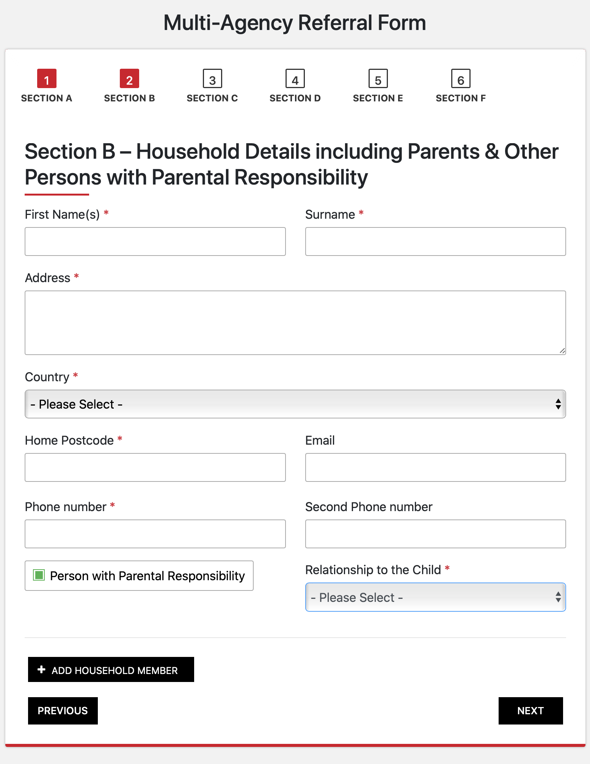

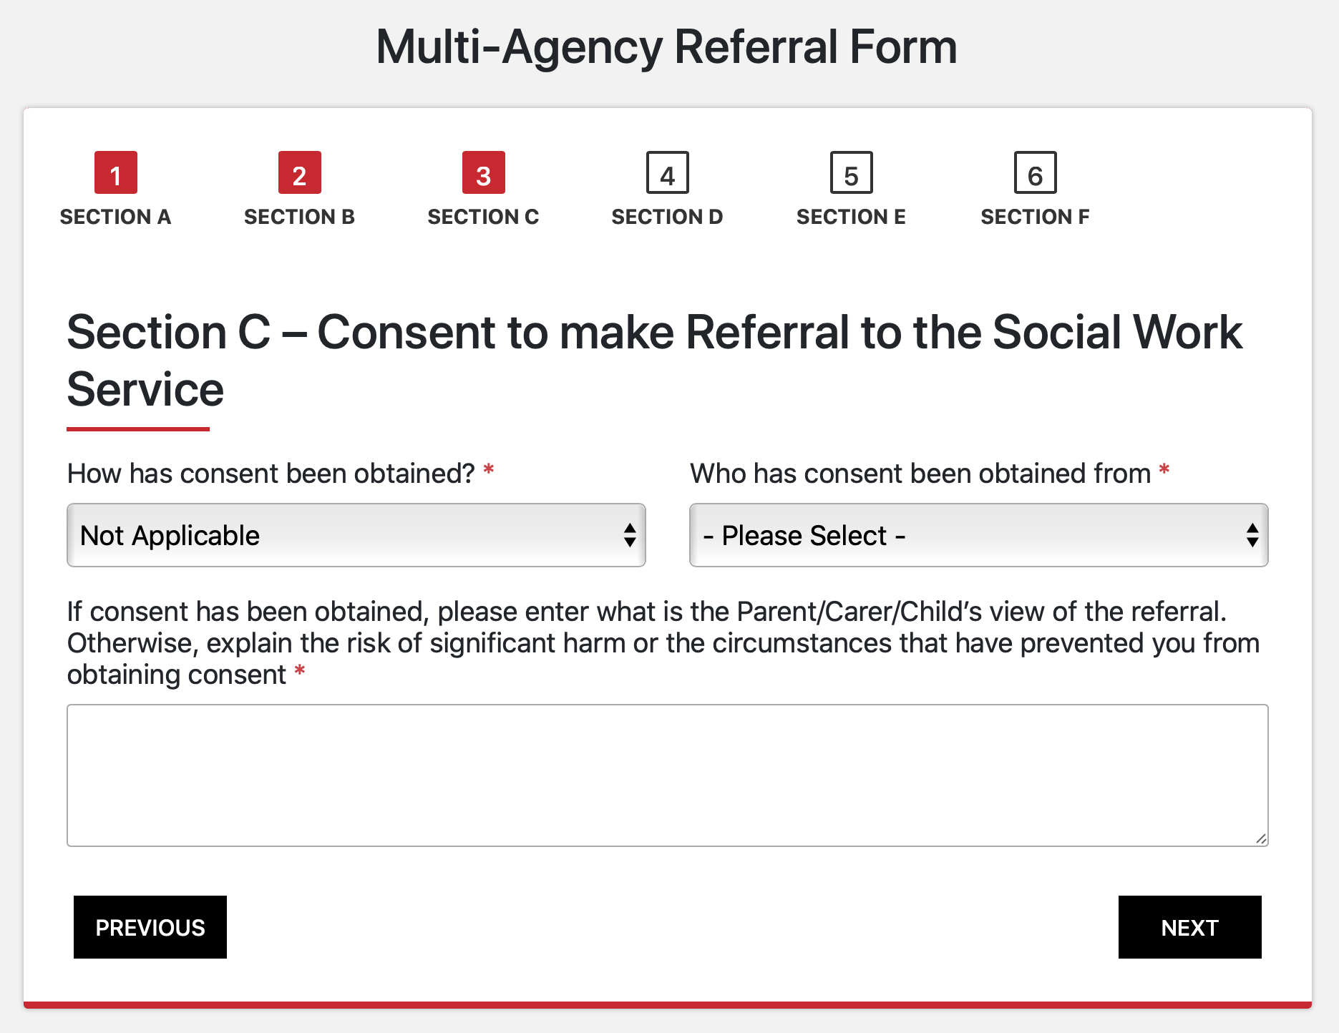

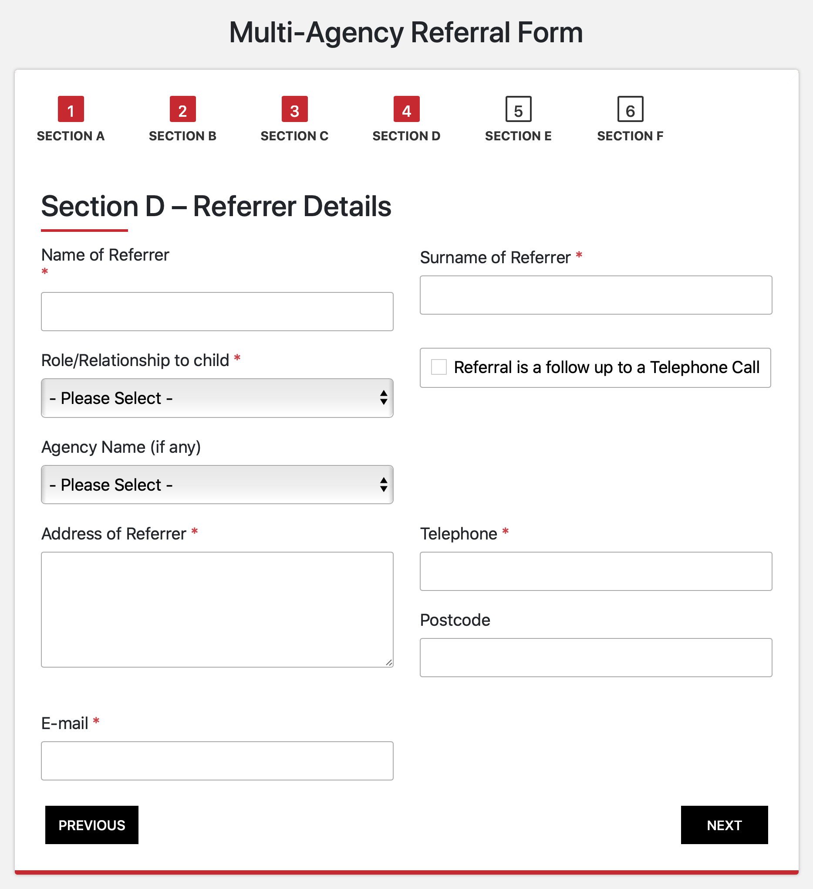

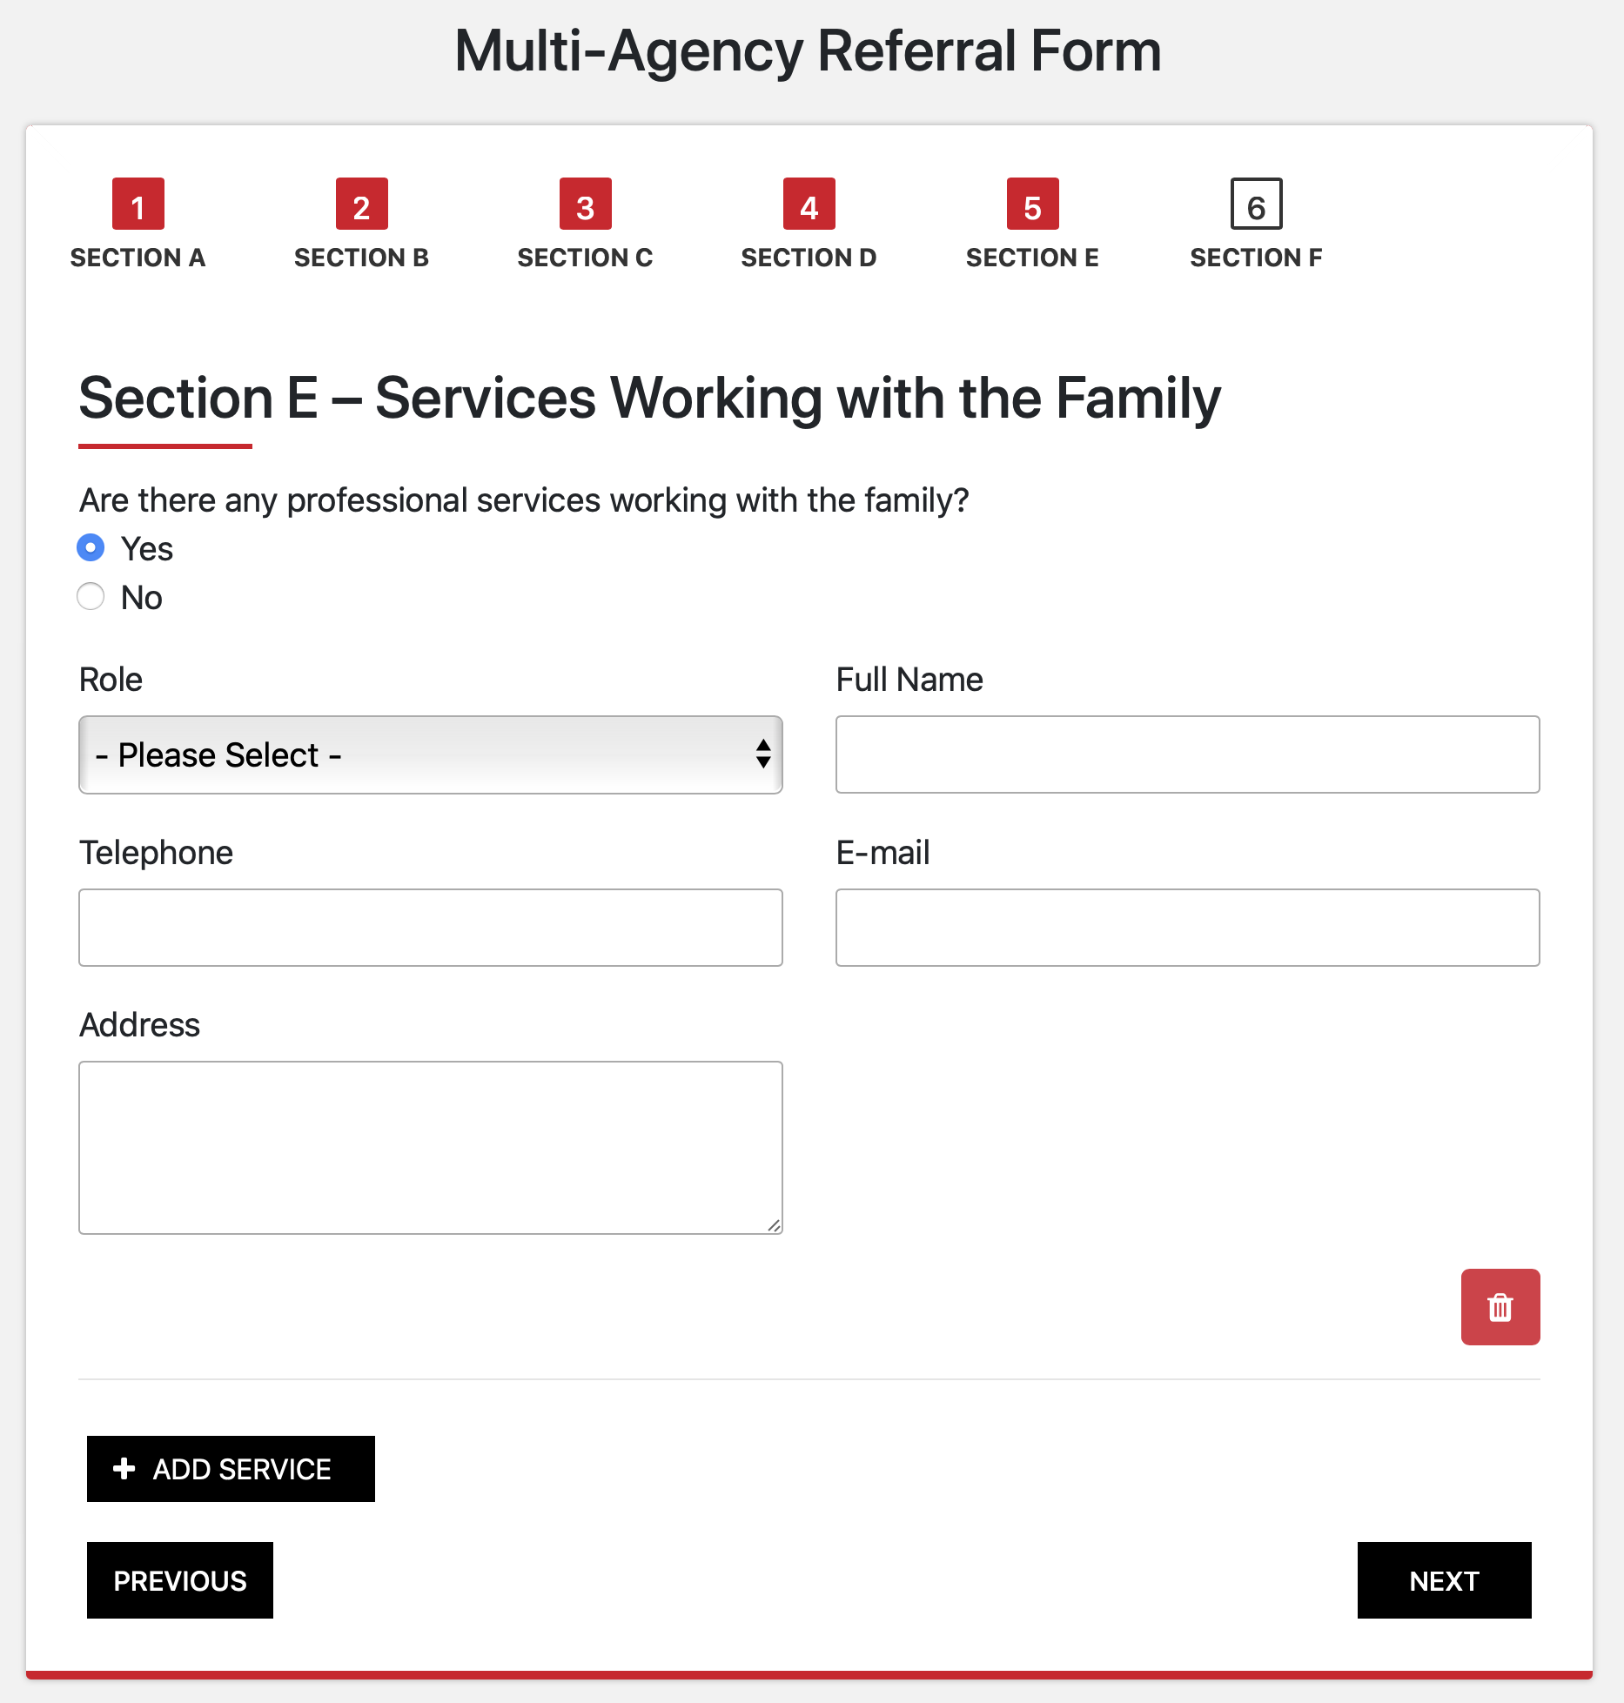

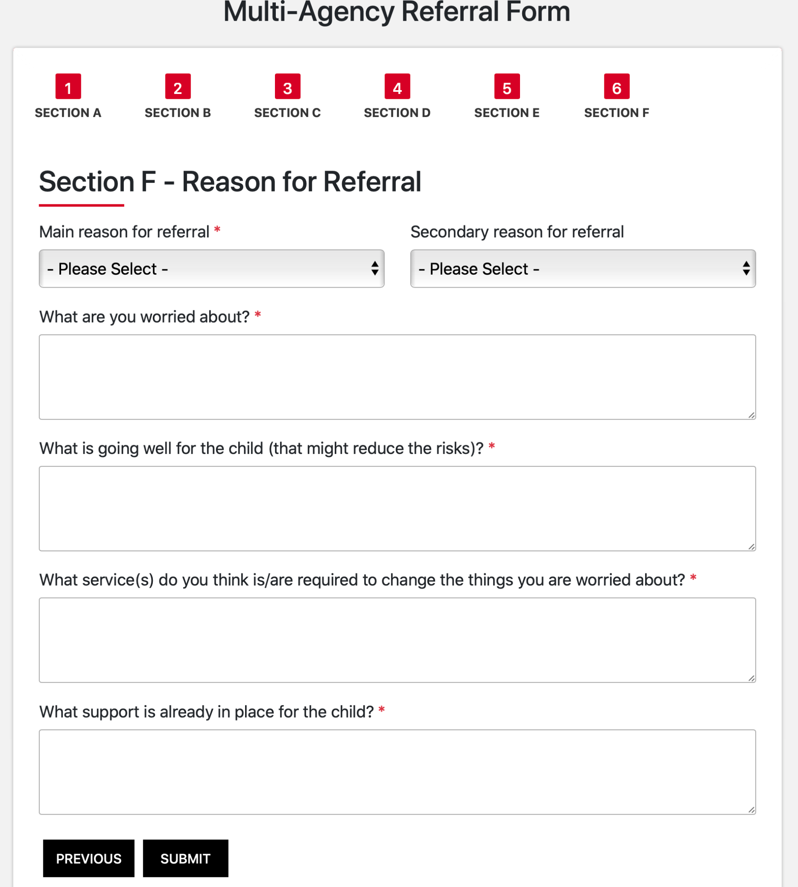

## Appendix 4

## BFSWS Multi-Agency Referral Form (MARF)

## 

The MARF is a referral form that all professionals should complete when they have concerns about a MOD child in Gibraltar.

If you require an electronic copy of this referral form email crt.bfsws@coreassets.com or click on this link: [BFSWS MARF](https://docs.google.com/document/d/1zkNEYU7CzRRGZ4AUXpDt4mroA6bkUIpuFQkDbX6zkls/edit?usp=sharing)

Advice can also be obtained from:

* A MOD Central Referral Team Social Worker can be contacted on 0044 (0)808 168 3111.
* Nadine Gonzalez, Schools’ Liaison Officer - [Nadine.Gonzalez@modschools.org](mailto:Nadine.Gonzalez@modschools.org)
* CPO Jenni Wheldon, Case Worker, Royal Navy Family and People Support - [Jenni.Wheldon744@mod.gov.uk](mailto:Jenni.Wheldon744@mod.gov.uk)

**Multi Agency Referral Form**

**To The British Forces Social Work Service**

**IN THE FIRST INSTANCE ALL REFERRALS SHOULD BE DISCUSSED WITH A CRT SOCIAL WORKER, WHO WILL EITHER:**

**A. AGREE TO ACCEPT THE REFERRAL**

**B. DIRECT YOU TO MORE RELEVANT SERVICES.**

**C. AGREE NO FURTHER ACTION IS REQUIRED.**

**Contact the Central Referral Team (CRT) on:**

**0044 (0)808 168 3111**

**You must have consent from the child/family to submit this referral unless there is a risk of significant harm. This will have been discussed in your consultation with CRT**

|  |  |  |  |  |  |  |  |
| --- | --- | --- | --- | --- | --- | --- | --- |
| **THIS INFORMATION IS PROVIDED BY:** | | | |  | | | |
| **TITLE/DESIGNATION:** | |  | | | | **DATE:** |  |
| **ADDRESS:** |  | | **BFPO:** | |  | | |
| **CIVILIAN TEL NO:** | |  | | |

|  |  |  |  |  |  |  |  |  |  |  |  |
| --- | --- | --- | --- | --- | --- | --- | --- | --- | --- | --- | --- |
| **Family Name(s):-** | | | | | | | | | | | |
| **Surname** | | **Forenames** | **Previous Names / Known As** | **Date of Birth** | | **Sex** | | **Relationship** | | **Ethnicity** | **Nationality** |
|  | |  |  |  | |  | |  | |  |  |
|  | |  |  |  | |  | |  | |  |  |
|  | |  |  |  | |  | |  | |  |  |
|  | |  |  |  | |  | |  | |  |  |
|  | |  |  |  | |  | |  | |  |  |
|  | |  |  |  | |  | |  | |  |  |
|  | |  |  |  | |  | |  | |  |  |
| **MARRIED QUARTER ADDRESS:** | | | | **HEAD OF HOUSEHOLD:** | | | | |  | | |
|  | | | | **NO:** | | |  | | | | |
| **RANK:** | | |  | | | | |
| **NAME:** | | |  | | | | |
| **UNIT:** | | |  | | | | |
| **ADDRESS:** | | |  | | | | |
| **TEL NO:** |  | | | **BFPO:** | | |  | | | | |
| **HAS THERE BEEN ANY EARLY HELP INVOLVEMENT?**  **IF YES, EARLY HELP ASSESSMENT IS ATTACHED? YES / NO**  **If not attached, the date this will be forwarded to BFSWS …………/……….…/…………..** | | | | | | | | | | | |
| **Professionals involved (name, agency and contact details)** | | | | | | | | | | | |
|  | | | | | | | | | | | |
| **DOES THE SUBJECT/FAMILY CONSENT TO OR KNOW OF THIS REFERRAL?** | | | | |  | | | | | | |
| **HOW HAVE THEY BEEN INFORMED?** | | | | |  | | | | | | |
| **ARE THERE ANY COMMUNICATION DIFFICULTIES?**  **(IS AN INTERPRETER REQUIRED)** | | | | |  | | | | | | |
| **What are you worried about?** | | | | | | | | | | | |
|  | | | | | | | | | | | |
| **What is working well?** | | | | | | | | | | | |
|  | | | | | | | | | | | |
| **Are there any complicating factors?** | | | | | | | | | | | |
|  | | | | | | | | | | | |
| **What action have you already taken to address the concerns?** | | | | | | | | | | | |
|  | | | | | | | | | | | |

**Once completed this form should be sent to CRT within 48 Hours of it being agreed that a referral should be submitted**

**Email:** [crt.bfsws@coreassets.com](mailto:crt.bfsws@coreassets.com)

Please confirm receipt of referral

**Original signed: Signature of Referrer:**